 | Case No. ADJ10669666
JOHNNY NAVA,
Applicant,
vs. | NOTICE OF INTENTION  to change venue  to long beach
LEES CONSTRUCTION;
SCIF INSURED EUREKA;
Defendants.

IT APPEARING THAT defendant having filed an Objection to and Petition for Change of Venue dated 12/21/2016, and;
NOTICE IS HEREBY GIVEN that unless objection is received within ten (10) days from the date of service as set forth herein, an order transferring venue to the Long Beach District office will issue.

DATE: 12/23/2016 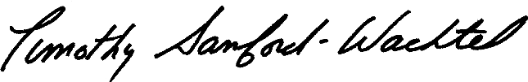
Timothy Sanford-Wachtel
presiding workers' compensation
administrative law judge
SERVICE:
JOHNNY NAVA, US Mail
MISHERGHI LAW RIVERSIDE, Email
SCIF INSURED EUREKA, US Mail
Service made on all parties as shown on Official Address Record
ON: 12/23/2016
BY: L. Savalza

